**GRADE 8**

**Unit 1: My Friend**

**I. VOCABULARY**

|  |  |  |  |  |
| --- | --- | --- | --- | --- |
| **#** | **Word** | | **Meaning** | **Example** |
| 1 | **Base** | **fair** /fer/(adj.) | trắng (da), vàng nhạt (tóc) | *She has long****fair****hair.* |
| 2 | **Base** | **introduce** /ˌɪntrəˈdjuːs/  (v.) | giới thiệu | *I would like to****introduce****you to our principal.* |
| **Derivatives** | -introduction /ɪntrəˈdʌkʃ(ə)n/ (n.)  -introductory /ɪntrəˈdʌkt(ə)ri/ (adj.) | -sự giới thiệu, lời giới thiệu  -mở đầu, giới thiệu | *-* *Donna quickly made the* ***introductions.***  *-Beginners will have two* ***introductory*** *lessons.* |
| 3 | **Base** | -please /pliːz/ (interjection)  -please /pliːz/ (v.) | -vui lòng, làm ơn  -làm hài lòng | *-Would you help me with these bags, please?*  *-* *He’ll do anything to please her.* |
| **Derivatives** | **pleasure** /ˈpleʒər/(n.) | điều thú vị, niềm vui thích | *It gives me great****pleasure****to introduce our guest speaker.* |
| 4 | **Base** | **principal** /ˈprɪnsəpl/(n.) | hiệu trưởng | *Mr. Hung is the****principal****of Thang Long primary school.* |
| 5 | **Base** | **seem** /siːm/(v.) | có vẻ như, dường như | *He is 16, but he****seems****younger.* |
| **Derivatives** | -seeming /ˈsiːmɪŋ/ (adj.)  -seemingly /ˈsiːmɪŋli/ (adv.) | -có vẻ, ra vẻ  -có vẻ như,  dường như | *-He tried to behave with seeming sincerity.*  *-Heidi was seemingly calm when she left to take the test.* |
| 6 | **Base** | -**slim** /slɪm/(adj.)  -slim / slɪm/ (v.) | -thanh mảnh, mảnh dẻ  -làm cho người thon gọn | *How do you keep so****slim****?*  *-* *You can still eat breakfast when you are slimming.* |
| 8 | **Base** | **straight** /streɪt/(adj.) | thẳng | *She has long****straight****hair.* |
| **Derivatives** | -straighten /ˈstreɪt(ə)n/ | làm thẳng | *He put on his jacket and straightened his tie.* |
| 9 | **Base** | **bald** /bɔːld/ (adj.) | hói đầu | *He has a bald spot on the top of his head* |

**II. LISTEN & READ ( không cần viết vào tập)**

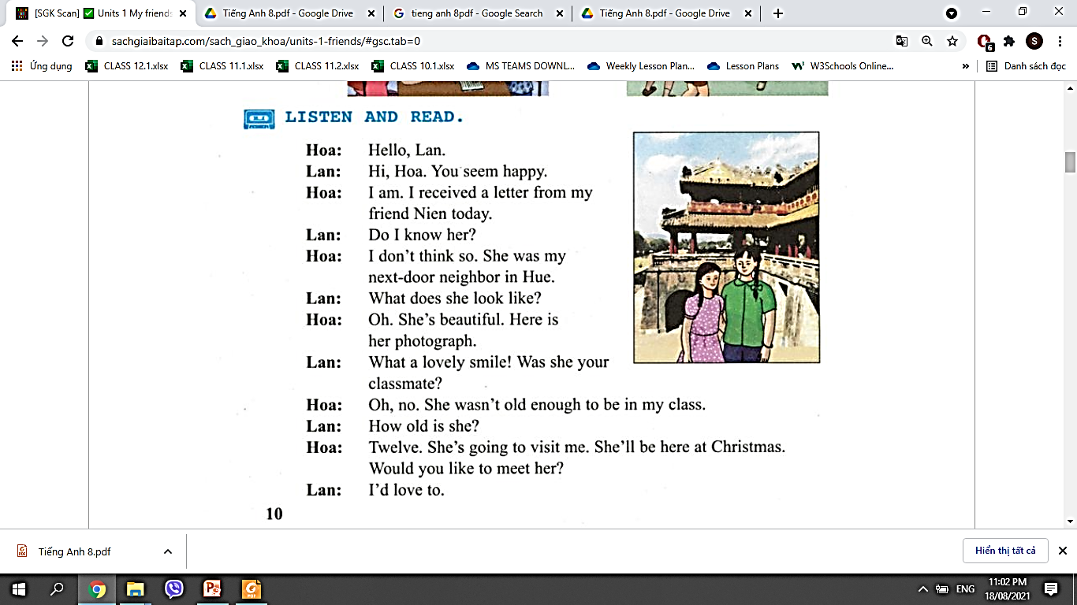

1. **Listen and practice the conversation above**
2. **Answer the following questions.**
3. Is Hoa happy? Why?

…………………………………………………………

1. Was Nien Hoa’s classmate?

…………………………………………………………………

1. Where does Nien live?

………………………………………………………………..

1. What does Nien look like?

………………………………………………………………….

1. Does Lan know Nien? Give reasons for your answer.

………………………………………………………………….

1. Is Hoa older than Nien? Give reasons for your answer.

…………………………………………………………..

1. When is Nien going to visit Hoa?

………………………………………………………….

1. Is Lan interested in seeing Nien?

…………………………………………………………

**III. SPEAK**

1. **Read the conversation below and then practicing describing the following people:**

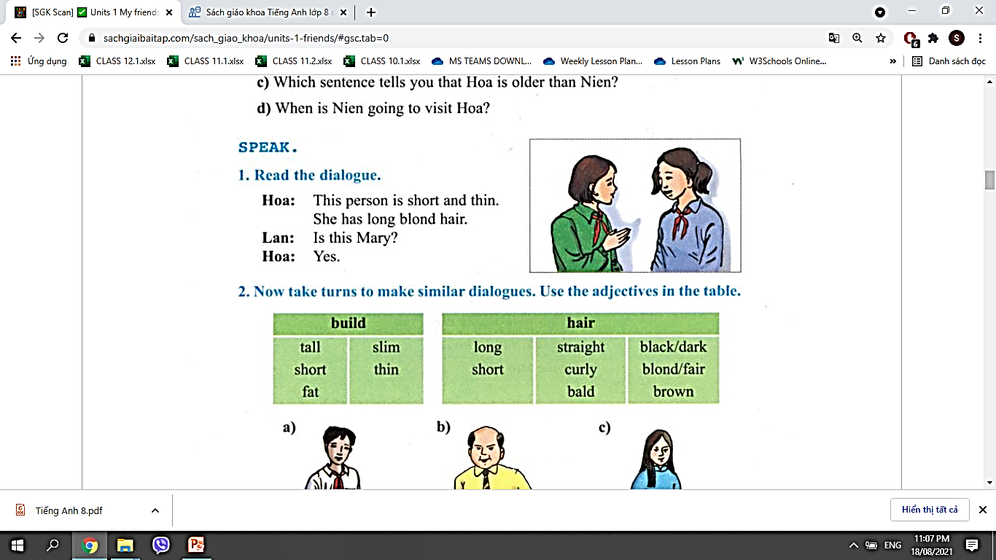

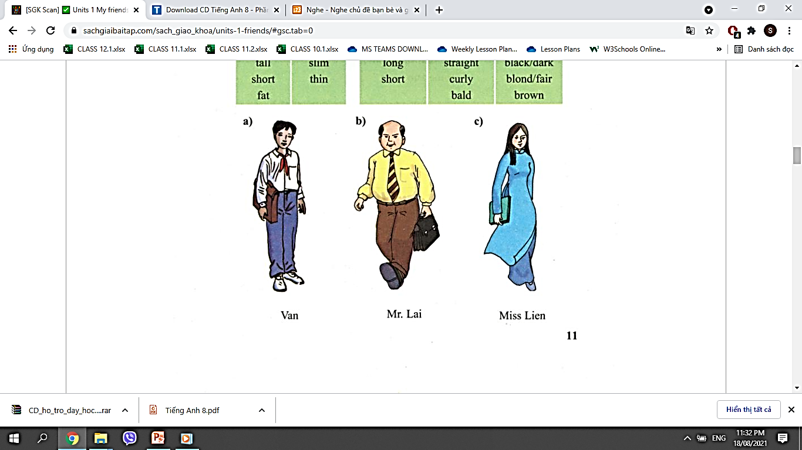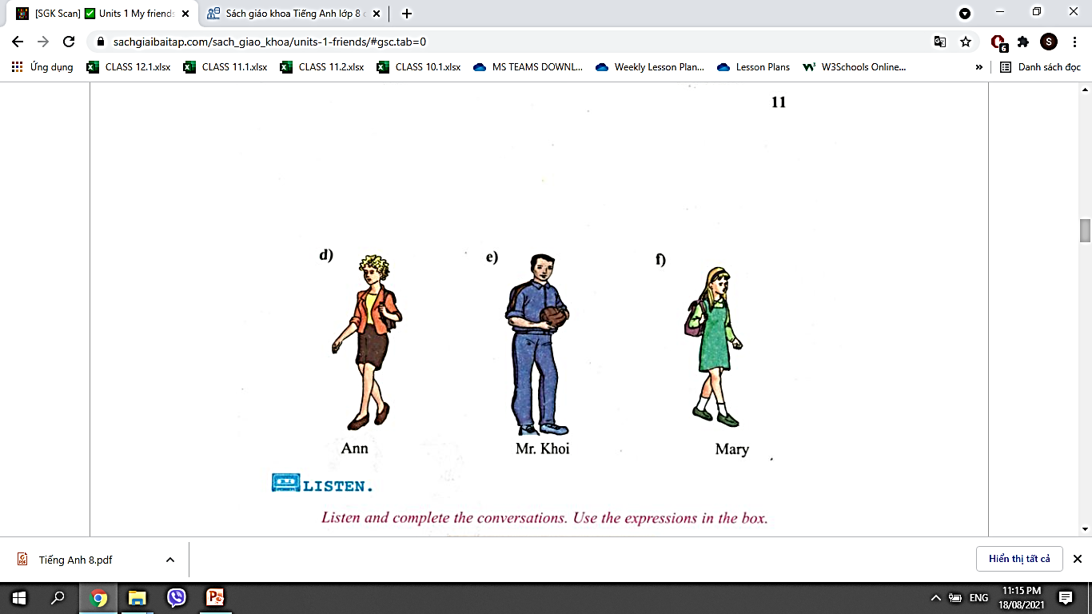

1. **Read the following conversation and complete it with the given words below:**

|  |  |  |  |  |  |
| --- | --- | --- | --- | --- | --- |
| **like** | **dark** | **excellent** | **Who** | **What** | **good-looking** |

**Loan:** Hello, Hoa.

**Hoa:** Hi, Loan. Where were you last Sunday?

**Loan:** I went to Ha Long Bay.

**Hoa:** Who did you go with?

**Loan:** With some of my classmates and Paul.

**Hoa:** ____ (1) _____ is Paul?

**Loan:** One of my friends. He's from France. Now he's studying at UKA.

**Hoa:** ____(2)_____ does he look like?

**Loan:** He is_____(3)_____ , with_____ (4)____ hair and big brown eyes.

He is very friendly.

**Hoa:** Can he speak English?

**Loan:** His English is____ (5) ____ !

Hoa: Really? I hope to see him one day. I_____ (6)___ talking to him in English.